ROVotron Cadet ROV Kit

Assembly and User Guide

Introduction
This instruction manual describes how to build the Rovotron Cadet ROV kit.
The Rovotron Cadet underwater ROV kit is designed to allow a team with a limited budget to build and operate an ROV that is capable of competing successfully in a contest such as NURC. The kit contains all the parts needed to build the ROV, tether, and control box.
You will need to provide some tools, batteries and an XBox gamepad and analog TV or monitor.
You will also need to program the two Teensy computers in the robot and the top box.
The instructions for the two circuit boards are provided separately so that they may be built at the same time as the ROV itself.
See the details on the next page.

About Underwater Robotics
Underwater robotics is an exciting field. It’s possible to have a little machine drive around in the water under your control, while you stay dry and breathe air on the land. The robot can see what’s in front and below it, with a video camera that sends a real-time moving image to a video screen in front of you. The robot can move in any direction: left, right, up down, forwards, backwards. It can spin around if needed to get a quick view of the entire surroundings.
The typical NURC mission takes place at night. A headlight on the robot allows you to see in the dark water.

The Rovotron Cadet ROV
The robot has a small, streamlined shape and enough power to move quickly through the water, forwards, backwards, around corners and up and down. An optional strafing thruster allows the robot to be easily moved side-to-side to view and manipulate objects as required in challenges.
A high quality analog video camera allows the driver to see the entire area in front of the robot on a TV or monitor. The camera may be tilted up or down with the controller to view the floor or the surface of the pool. A bright, dimmable LED headlight lights up the scene for driving at night.
The basic Cadet kit ROV does not have any actuators. It can drive through the pool, look around, illuminate the scene, and poke at things with a stick. It is up to the team to adapt the kit for the particular mission being performed, which varies from event to event.
An optional Gripper kit is available, as is an optional strafing thruster.
The Theory of Operation section at the end of this manual has a thorough description of the ROV design.

Getting started building the kit
Building the Rovotron Cadet takes a couple of days. It’s best to follow the instructions carefully, because there are many details of robot construction that can be done wrong and will cause you grief later. This kit and instructions have been meticulously created to allow you to succeed in getting a fully functioning ROV into the water and driving around.
It’s tempting to take shortcuts or to think that you know what comes next. Please resist that temptation. The experience of the kit designers has shown that shortcuts lead to failure. This kit is as simple as it can possibly be, yet still result in building a high-performance robot that doesn’t leak.

Time required
The kit will take several days to assemble. Take your time. When you stop for the day, be sure to keep all the parts safe and together with the kit, so that none are lost or borrowed.

Build sequence
Your ROV kit has two circuit boards RVCBOT and RVTOP. These boards may have been provided already assembled if your kit was ordered that way. If that is not the case,
they may be built by other team members while the hull and Noggin are being built by one group. Each board kit is in a separate anti-static bag. The assembly instructions are on different pages to allow different groups to work on these subassemblies at the same time.

Accessories required
The kit doesn’t come with the following:
Two 12V SLA (sealed lead acid) batteries, 18 amp-hour (AH) (FRC batteries are good)
Automotive inline fuse holder and 20 amp fuse
Terminals to connect the fuseholder and tether to the batteries, yellow crimp terminals are good
Xbox Gamepad or equivalent that speaks Xbox protocol
USB-A to USB-B Micro cable
Video monitor with yellow RCA jack analog NTSC input
(or HDMI monitor with NTSC-to-HDMI converter box and power supply)
Box to put the batteries in
Wiring from batteries to tether power cable, with fuse and power switch
Battery charger

Tools
The kit requires a set of hand tools to install screws and tighten nuts.
#1 Phillips screwdriver
#2 Phillips screwdriver
3mm or 1/8” slot screwdriver
2.5mm or 3/32” slot screwdriver
¼” nutdriver
¼” end wrench
5/16” or 8mm end wrench or nutdriver

Electrical tools:
X-Acto Knife and blade
Wire strippers 16-24 AWG e.g. Ideal 45-416
Side cutters, flush cut e.g. Hakko CHP-170
Ferrule crimper (Amazon B0BM473JG4 or equivalent)
Soldering iron if you’re building the boards

The Gripper requires some extra tools:
5/16” end wrench
5/16” nutdriver
1/16” hex key
2mm or 5/64” hex key

Computer:
Laptop running Windows, Linux or MacOS
Arduino IDE installed
TeensyDuino extension pack installed
USB on laptop to Micro USB cable (can use the gamepad cable)

Supplies required
Self-fusing tape
Painter’s tape
Solder if you’re building the boards, 0.031” rosin or no-clean flux

Robot assembly
The robot kit may be assembled by several groups of team members, each group working on a different part of the kit. The subassemblies that may be built separately include the circuit boards, the hull (frame/thrusters/tether), the top box, the Noggin and the optional Gripper.
Each subassembly has its own pages in this instruction manual. This allows teams to separate the manual into sections and have each section built by one group of people.

The following chapters each describe a subassembly that may be assembled in any order.
Hull
Noggin
RVCBOT board
RVTOP board and box

The final assembly step must be performed after the Hull, Noggin and RVCBOT board are complete. It ties all these parts together into a finished ROV.

First, take inventory. Check that all parts are present. This check will also familiarize you with the parts of the ROV.

The small parts are provided in several bags. The bags are:
Hull hardware
Noggin plastic
Noggin hardware
Final hardware
RVCBOT board
RVTOP board
Top Box plastic

Additionally, there are large parts packed separately:
Hull port side
Hull starboard side
Hull end cap
Hull handle
Ballast bars
Noggin tube
Tether data cable
Tether power cable
Tether flotation foam

Hull Assembly
The hull consists of two side plates, a handle, and two ballast bars. It has thrusters bolted to it. The tether and thruster cables are permanently attached to the starboard (right) side plate using rubber seals, plastic rings and aluminum clamp plates.
The side plates are different from each other. The starboard (right) side plate has all the cable sealing glands. The port (left) side plate has a big hole where the removable end plug fits. The large O-ring groove in the starboard side plate faces the center of the ROV.
The fore end of the robot is the end with the Noggin. The aft end is curved downward and has the carrying holes.
The two ballast bars each have threaded holes in each end to connect to the side plates. The H-shaped handle has unthreaded holes. These parts are symmetrical.
The tether is braided from an Ethernet cable, speaker wire and a shorter length of foam backer rod. It’s taped together at the ends to prevent fraying.

Assembly steps:

1-3) Connect the handle to the inside of the top of the starboard plate (the side with the big round groove) with two #10 x 1.25” self-tapping screws. Make sure the strafing motor mounting pad is to the back of the handle. See the picture on the next page.
Set the starboard plate flat with the handle and ballast bars sticking up.
Connect the handle to the port plate using the other two #10 self-tapping screws.
4-5) Insert the front ballast bar between the two plates and insert a 10-32 screw through the port plate in the hole just below the large tube hole, near the front.
Do the same for the rear ballast bar.
Flip over the frame onto the port side and insert two 10-32 screws into the ballast bars.
Flip the ROV onto its bottom and tighten all screws snug.

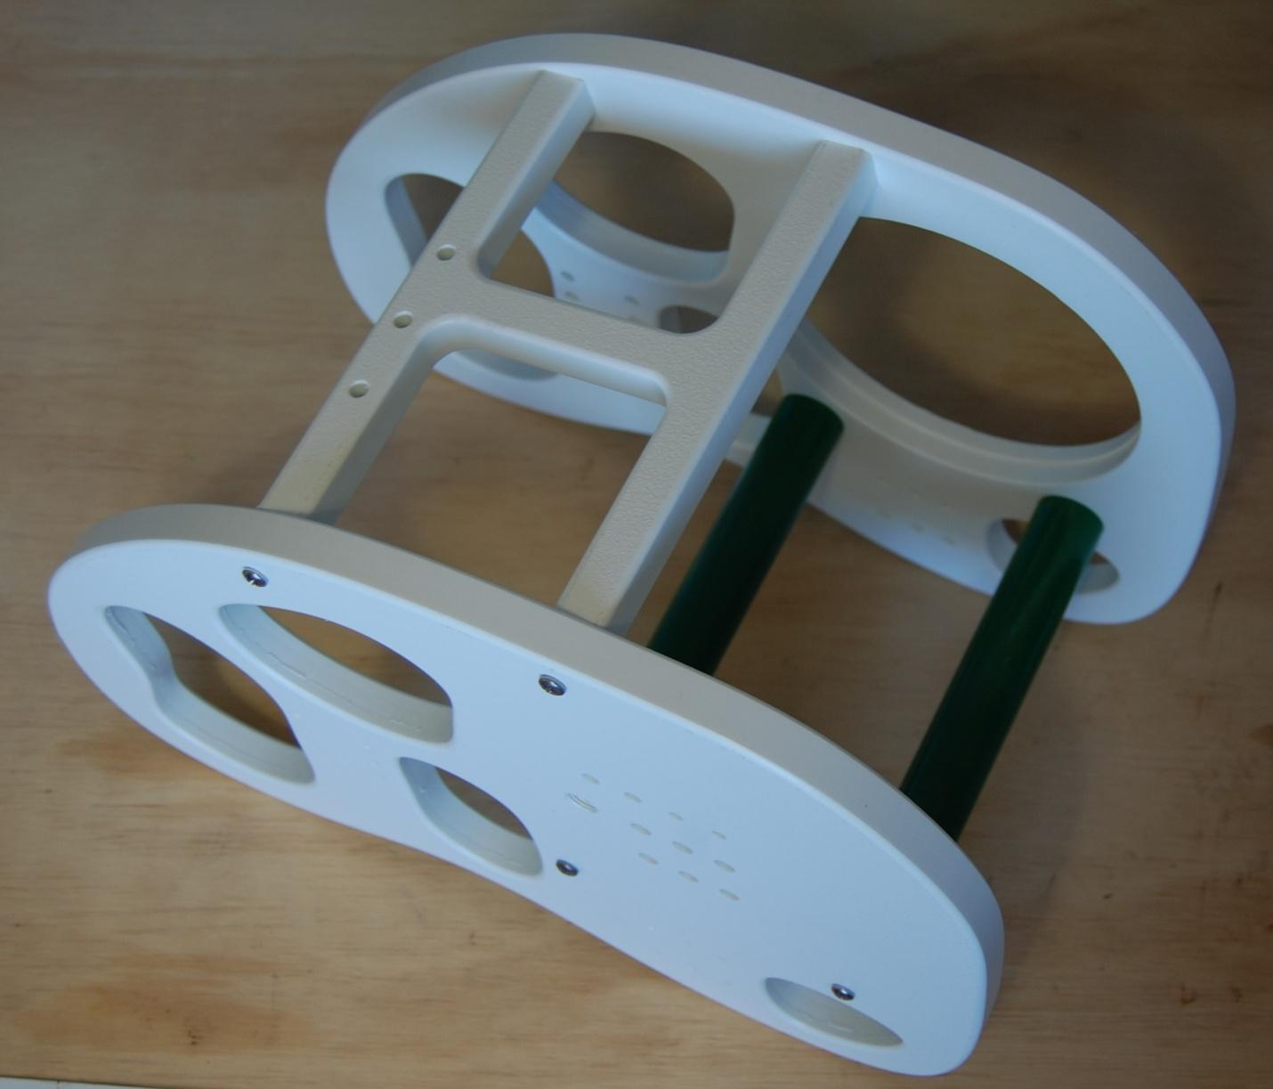

Thrusters
7) The kit contains four or five thrusters, depending on whether the strafing thruster option was ordered. Two or three of them are labeled CW, the rest are labeled CCW.
The two pairs of CW and CCW thrusters are to be used for the fore-aft and up-down thrusters, CCW on one side and CW on the other side. This method of using counter-rotating pairs prevents the thrusters from causing the ROV to twist when accelerated.
The thruster mapping is tabulated below.
Len. is the length to cut the cable on the thruster. It is in INCHES. Double check the measurement, as it’s not possible to replace the cable if it’s cut too short!
Penetrator refers to the two rows of three cable entry holes on the starboard side plate.

Thruster Motor Rot. Length Penetrator Hole
L up-down 1 CCW 25 in Top fore
R up-down 2 CW 12 in Bot fore
L fore-aft 3 CW 24 in Top mid
R fore-aft 4 CCW 14 in Bot mid
Sideways 5 either 15 in Top aft

Each cable needs to have 5 inches of the jacket removed to reveal the three wires inside. This must be done carefully to avoid damaging the insulation on the wires. It’s a good idea to practice removing the jacket from a few of the cut-off lengths of cable first, to get the hang of the process.
The jacket is removed by carefully scoring the jacket all around the cable with an Xacto knife, taking care to not cut into the wires inside. Pull on each end of the jacket to stretch the jacket as it is cut, to make it easier to see when the jacket separates.
There is a layer of white paper around the wires. Cut this off nearly flush with the end of the jacket. It doesn’t have to be perfect, as you won’t be able to see it later. The wires will be terminated later in the assembly process.
8) Mount each thruster in its specified location the screws (3) that are provided in the kit, and put its cable into the appropriate penetrator hole. Do not use the screws that come with the thrusters. Note that the thrusters will be mounted so the cable side of the thruster is closest to the holes for the wires.

Cable seals
The starboard side of the robot has three rows of holes for cables. Each hole has a counter-bored recess around it on the inside, and screw holes above and below. These holes are used for the cable seals.
The top row has two small power cable holes, one for each wire, and two larger holes for the data tether and a spare for a temperature sensor or other user function.
The bottom two rows each have three holes for thrusters.
There are three different sizes of cable seals for these cables.
Included in the kit are three sizes of rubber seals made from automotive vacuum hose.
Also included are three sizes of laser-cut rings used as compression washers to press the seals into the side plate.
Finally, there are three varieties of seal plates. Each seal plate has three holes: a center hole for the wires, and two screw holes for the clamping screws. The center hole for the thruster and data clamp plates is smaller diameter than the cable jacket.
The clamping screws are special self-threading screws designed to be installed with a ¼” nutdriver. They require a bit of force to get tight, but must not be over tightened.
DO NOT use a power tool to install the clamps since they need to be tightened carefully to avoid stripping the threads.
If you strip the clamp threads, then your robot will leak water and you will be VERY SAD. Your mentor will make you go to the store to buy some TAMPONS to sop up the mess,and you’ll be extra embarrassed. If you don’t believe me, watch the movie ‘Spare Parts’.

The procedure for installing a thruster cable is:
Push the cable through its hole from the outside to the inside.
10) Put a bit of silicone grease on the rubber seal.
Place the rubber seal around the wires, slide it down to the side plate and press it into the hole
11) Place the large plastic ring around the wires and slide it to touch the seal.
12) Place the correct metal clamp plate around the wires (using center hole) and slide it to the ring.
Push the cable from the outside to be sure that the end of the jacket is making contact with the plate.
13) Put two #8 x ½” self-threading screws into the end holes of the plate.
Alternately screw in the two screws with ¼” nutdriver, making sure that they go in straight.
Tighten the two screws alternately a half turn at a time until they are hand-tight (don’t overexert). The metal clamp does NOT need to be in contact with the plastic hull, there may be a gap.
Test the clamp by trying to pull the wire out. It should resist a few pounds of pulling force.
Repeat this procedure for each thruster cable.

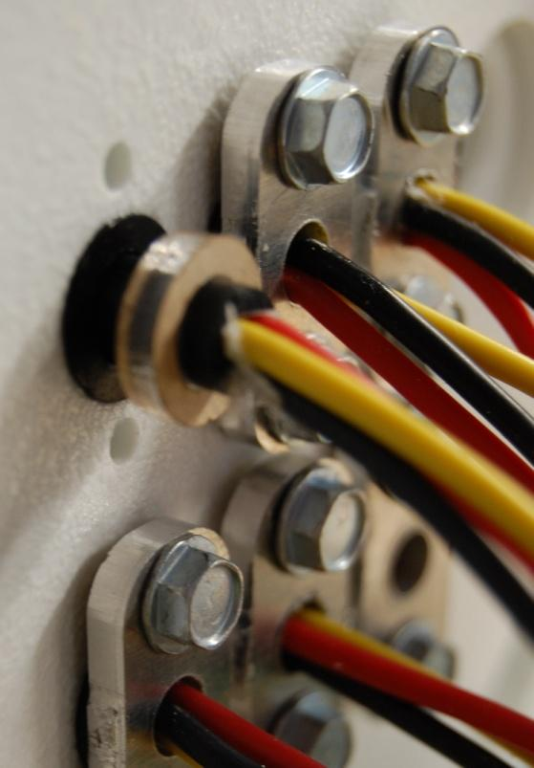

Tether
The tether is made of four items: the data cable which is an Ethernet cable, the power cable which is speaker wire, the float which is ‘foam backer rod’ used to seal doorways in home construction, and self-fusing tape to hold the ends of the float to the cables. The three long items are to be braided together to make one continuous, snag-free rope that connects the robot to the control box on shore. The self-fusing tape ensures that the foam doesn’t unwind from the tether.
The foam isn’t used within 6 feet of the robot, nor within ten feet of the shore end. The reason is that it would pull upward on the robot, and the shore end is on land so it doesn’t need to float.
The braiding procedure requires two people and a special technique.
The tether components are each provided as a coil of cable.

14-15) Tie the Ethernet plug and one end of the 12-2 cord to a stationary object at the end of a very long hall. The tether is 75 feet long, but the braiding work can be done in stages if you don’t have that much room.
16-17) Tape the foam to the other wires 15 feet from the end with self-fusing tape. Cut off a 4-inch-long piece of tape, remove the backing, and stretch it a lot as you wrap it around the cables. It sticks to itself, which explains the name. The result should be a sturdy joint without any loose ends.
Two people perform the braiding operation. Each of the three cables (Ethernet, power, foam) is a coil that gets unrolled slowly as they are passed over each other. Right person takes the leftmost coil over the center coil, then the left person takes the right coil over the center coil. Each time they hand off coils as needed. Repeat the process of left over center, right over center, left over center....
It’s good to say out loud “Left, right, left, right, …) ad the coils are lifted over each other.
The braid overlap length wants to be about two cycles of three overs per foot. When you reach the end of the foam, tape it to the other wires with self-fusing tape, and the tether is done.

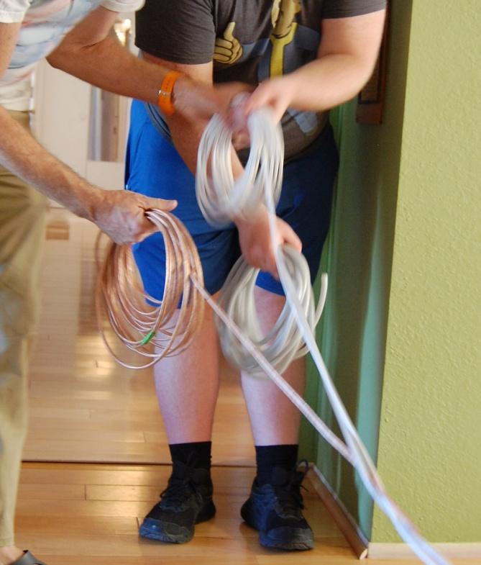

Tether ends
The tether has two ends: the robot end and the shore end. The robot end doesn’t have an Ethernet plug! It has a raw cable end.
At the robot end of the tether (the end without a plug), lay the data and power cables out straight past the end of the foam. Twist them together, about one twist per foot, and wrap some painter tape around the two about two feet from the end. Then compare the lengths of the cables. Cut whichever cable needs to be cut, to make the white data cable five inches longer than the copper power cord.

The data cable needs to have about 10 inches of the jacket removed. This is done by carefully scoring the jacket all around the cable with an Xacto knife, taking care not to cut into the wires inside. The jacket can then be pulled off to reveal the four twisted pairs of wire inside: green, orange, blue and brown. Leave the wire pairs twisted around each other for the next step.
18) The data tether needs to have a brass tube inserted into the jacket to provide a solid surface for the seal to work properly. The brass tube is one inch long and just fits over the wires. Slide the brass tube over the four pairs of wires, taking care to keep the pairs twisted around each other as they were in the jacket so they are compact enough for the tube to slide over them.
Push the brass tube into the jacket about half an inch. This may be difficult. You may heat up the jacket slightly with a heat gun, to make it more flexible. Don’t melt it!
Push the data cable through the forward of the two large top holes from the outside to the inside.
19) Put a bit of silicone grease on the medium-size rubber seal.
Place the rubber seal around the wires, slide it down to the side plate and press it into the hole.
20) Place the medium-size plastic ring around the wires and slide it to touch the seal.
21) Place the correct metal clamp plate around the wires (using center hole) and slide it to the ring.
Push the data cable from the outside to be sure that the end of the jacket is making contact with the plate.
Put two #8 x ½” self-threading screws into the end holes of the plate.
Alternately screw in the two screws with ¼” nutdriver, making sure that they go in straight.
Tighten the two screws alternately one turn at a time until they are hand-tight (don’t overexert). The metal clamp does NOT need to be in contact with the plastic hull, there may be a gap.
Test the clamp by trying to pull the wire out. It should resist a few pounds of pulling force.

The tether power cord needs to be split in half (unzipped) about six inches at each end. This is best done carefully with an Xacto knife, by setting the cord on a workbench and dragging the knife blade along the groove between the wires, with the handle held at a low angle to ensure that the blade doesn’t wander and slice open the insulation of either wire. Repeat for the other end.

Push the two power wires through the two small top holes from the outside to the inside. Pull about 4 inches of wire through the holes
22) Put a bit of silicone grease on the two small rubber seals.
Place the rubber seals around the wires, slide them down to the side plate and press into the holes.
23) Place two small plastic rings around the wires and slide them to touch the seals.
24) Place the correct metal clamp plates around the wires (using center hole) and slide them to the rings.
Put two #8 x ½” self-threading screws into the end holes of the plates.
Alternately screw in the two screws with ¼” nutdriver, making sure that they go in straight.
Tighten the two screws on each clamp plate alternately one turn at a time until they are hand-tight (don’t overexert). The metal clamp does NOT need to be in contact with the plastic hull, there may be a gap.
Test the clamps by trying to pull the wire out. It should resist a few pounds of pulling force.

25) There are a few unused cable holes that need to be sealed. These are to be sealed with the ¼” diameter plastic dowels in the kit. Use the same procedure above as you used for the cables.

Ensure that there are no visible open holes in the area where the cables enter the robot! You do not want leaks.
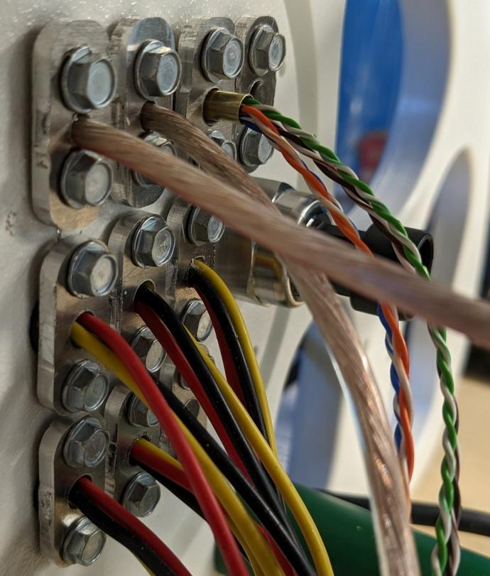

Pressure Sensor
26-27) Install the pressure sensor seal on to the sensor. Just push it over the threads.
Screw the sensor into the starboard plate, from the inside, in the large threaded hole. Be careful to thread it in straight. If it gets cross-threaded, it will leak!
Tighten it gently with a 24mm or 15/16” wrench or a pair of Channelok pliers, so as not to pull out the threads in the plastic.

End cap locking tabs
The end cap is retained in the ROV by two locking tabs in the port hull plate, located near the large opening for the end cap. These tabs are held in place with two 6-32 screws and locknuts. A washer under each tab keeps it from scraping the hull plate.

Install the two end cap locking tabs using two 6-32 x 1.5” screws and 6-32 locknuts. Place a #6 washer under each tab before installing it.

Noggin Assembly
The Noggin contains the brains of the robot. It is a plastic frame to which the control board, camera, LED and camera tilting servo are mounted. It has been carefully designed to make a neat and functional robot brain with minimal messy wiring.

The Noggin is made of a set of 3mm thick, clear cast acrylic laser-cut shapes.
These are numbered to make identification easier.

Lower Base 1
Upper Base 2
Braces 3 and 4
Plate 5
Camera servo 6 and 7
Camera pivot 8 and 9
Camera plate 10
Servo mount 11 and 12
Baffle 13
Port base 14

Noggin parts preparation
The first step is to peel off all the paper from the plastic pieces. This is done with a fingernail or pair of tweezers to lift the paper at a corner of the part, then pull the paper gently while holding it up at a 45-degree angle.

The plastic pieces are assembled using 4-40 x 1/2” screws and square nuts to hold them at a 90-degree angle to each other. The square nuts will be pressed into the slots as shown in the Braces, Bases, Baffle and Servo mount parts.

Each piece has a front and a back. The front is identified by the number reading correctly. The nuts may be slid easily into a piece from the front, but not from the back. This is because the laser cutter cuts the edges at a slight angle. Install all nuts from the front of each piece.
The two Base pieces are nearly identical. The only difference is that Base 2 has tabs inside the rectangular cutout. These tabs engage with slots on the Plate and Braces.

13) Stack Base 2 on top of Base 1 before inserting a square nut into each cross slot as shown. It may take some effort to press the nuts into the slots in the double stack. You can press the nut on the workbench while pressing the piece down onto the nut to help push it into position.
The nuts in the Braces and Baffle are to be pressed partway into the piece so that the nut is centered, and its edges stick out the same amount on each side of the plastic.

The Plate 4 has small round and square holes at one end. These fit over the tabs inside the Base, so that the end of the Plate is flush with the bottom of the Base.
14) Insert two screws into the holes and screw them in most of the way, but leave them a bit loose so that the Plate may be flopped back and forth a bit.
Each of the Braces 3 fits into one end of the opening in the Base, so that it sits at right angles to the long edge of the Plate. Install screws into the end of each Brace, but do not tighten them. Move the Plate into position over the tabs on the Braces. It should form a box shape. Install two screws into each Brace through the holes along the Plate edges. Tighten the screws that hold the Plate and the Braces to the Base.

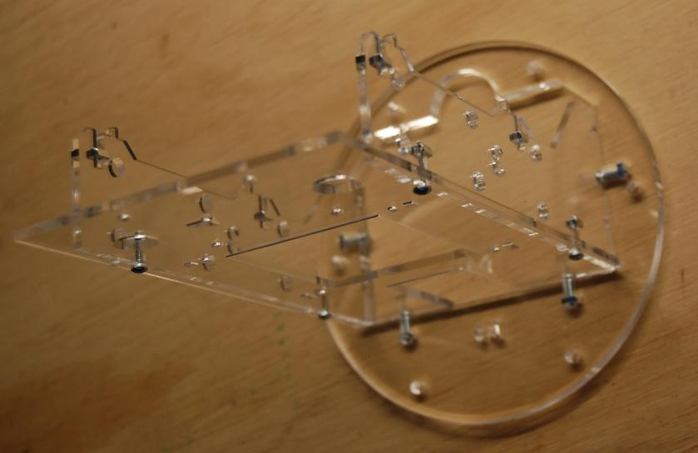

LED Preparation and mounting
15) The LED is provided in a silver baggie. It is delicate and sensitive to static electricity, so be careful with it.
The LED wires are soldered to the LED as provided. If not, cut the camera power cable in half, and use the half without the connector for the LED.
Strip 1/8” from one end of each wire and solder to the LED, Red to the + pad in one corner black to the other pad.
16) Examine the LED heatsink. One side is flat and has silver heat conducting tape on it. There are two holes drilled in the flat surface, diagonally arranged to fit the corner notches of the LED.
The LED is held to the heat sink with two screws. These are #4 x 5/16” self-tapping screws. They should be screwed into the heat sink holes first, then removed, to thread the holes without damaging the LED.
After the holes are threaded, screw one screw halfway into the heatsink. Place one corner of the LED (with a notch, not the corner with a wire) under the screw head. Screw in the other screw but don’t tighten it. Screw the first screw the rest of the way. Alternately tighten the two screws snugly. You might need to hold the LED in place as you tighten the screws. Don’t tighten them too hard, or the LED will be damaged.
18-20) Mount the heatsink to the noggin plate in the end away from the base. Use the four 6-32 x 1.5” screws, four #6 x 1” nylon spacers, and four 6-32 lock nuts. Put the screws through the heat sink holes from the LED side, then put a spacer on each screw. Place the assembly into the four holes on the plate with the LED facing away from the braces and with the fins running along the line between the two large holes. The photo below is wrong!
Thread the four nuts onto the four screws. Tighten the screws and nuts snug (not too tight) with a 5/16” or 8mm wrench and a #2 Phillips driver.

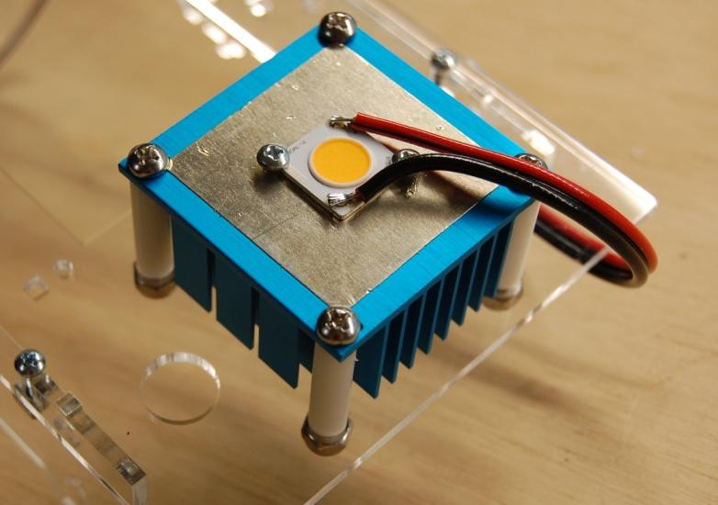

Camera
The video camera is assembled to the camera mount next. The camera is supplied in a small cardboard box. It comes with a metal mounting bracket that is not used. Remove the two screws from the sides of the camera and discard them and the mounting bracket.
Its cable has two connectors that give it power and provide the video signal. The video cable has a silver BNC jack. The power cable has a round, black barrel jack with a center pin.
The camera mount has several pieces. The camera plate is a rectangle with slots near each end to receive the servo and pivot assemblies.

Camera servo 5 and 6
Camera pivot 7 and 7
Camera plate 8
Servo Support 9 and 10
Pivot Support 11

21-22) The camera is held to the camera plate using two M2 x 8mm screws. The camera comes with its back plate held on with two M2 x 6mm screws. Remove and discard these screws. Mount the camera to Camera Plate 8, using the M2 x 8 screws. Put the camera on the side of the plate that allows the screw holes to line up and ensure that the camera cable goes through the notch.

The four small rectangular camera bracket pieces 5, 6, 7, and 7 are all the same size, but they have different holes. The stacking order is critical since each of these holes must be in the right place for the camera to be mounted to the servo.
Install two square nuts in the cross slots of plate 6 from the side that you can read the number. Push the plate down on the work bench, so the nuts pop up. Push plate 5 onto plate 6, so the nuts fit into the front face of plate 5.

Install two square nuts in the cross slots of either plate 7, from the side you can read the number. Push the other plate 7 onto the first, so the nuts fit into the front faces of both plates.

Install a 4-40 screw in the hole in the center of pivot support 11. Put a square nut on the other end of the screw, and tighten with a ¼” wrench. Install two square nuts into the cross slots.
Place the pivot support 11 on the plate 4, so it is next to the heat sink, and the tabs align with the holes. Attach with two screws.

Put two square nuts in the cross slots on servo support 10. Push the other servo support plate 9 onto the nuts, so that the servo mounting slot is aligned, not overlapping.
23) Place the servo into the opening, so the round part goes through the large rectangular hole, then the small rectangular hole, and is centered on the plate (not offset to one side).
Attach the servo with the two self-tapping screws provided in the servo package. These screws will thread into the holes in plate 9.

Place the camera servo plates 5 and 6 on to the servo shaft, so that the side with the tabs is next to, and parallel with, the long straight edge of the servo support plate, and so that the side with the larger center hole is towards the servo.
24) Push the splines of the plate onto the servo shaft part way, then install M2.5 x 6 servo horn screw, and gently turn it to engage the splines all the way.

Orient the noggin assembly as it would be when installed in the hull, so you can see which way is “up” and “forward”. The goal is to mount the camera to the servo assembly so that the camera is upright, with its cord at the bottom. Once you get it oriented properly, attach the camera plate to the servo and pivot assemblies, using four screws.

Mount the servo support to the main noggin plate 4, by first aligning the pivot screw on plate 11 with the hole in pivot plates 7, after routing the servo and camera cables through the holes on the noggin plate. Once the pivot is in place, align the servo support tabs with the holes in plate 4, and attach with two screws.

The Noggin is now assembled. It is time to build the circuit boards if they are not already built.

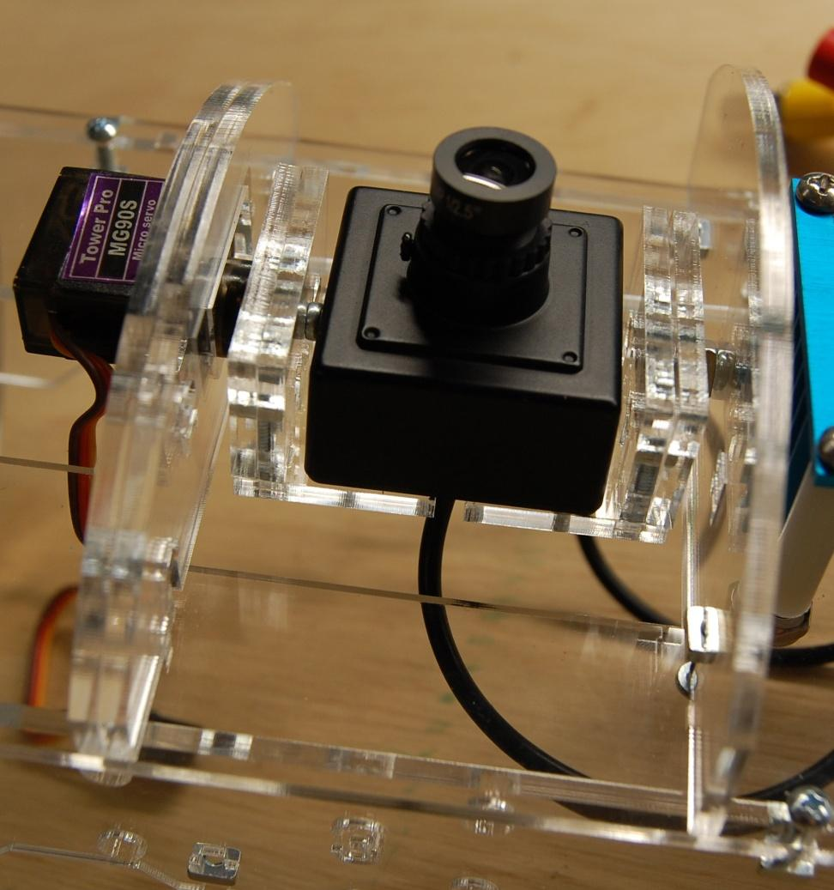

RVCBOT Board Assembly
The RVCBOT board is the ROV’s control center. It is a printed circuit board that holds a Teensy computer, five electronic motor speed controllers (ESCs) and a power distribution circuit. The board also has connectors for sensors.

Getting started
The ROV control board is called RVCBOT-D. This board is the brains of the ROV. A picture is included to show you what the completed board will look like after assembly. Please refer to this photo if you don’t understand the written instructions about how to assemble the board.

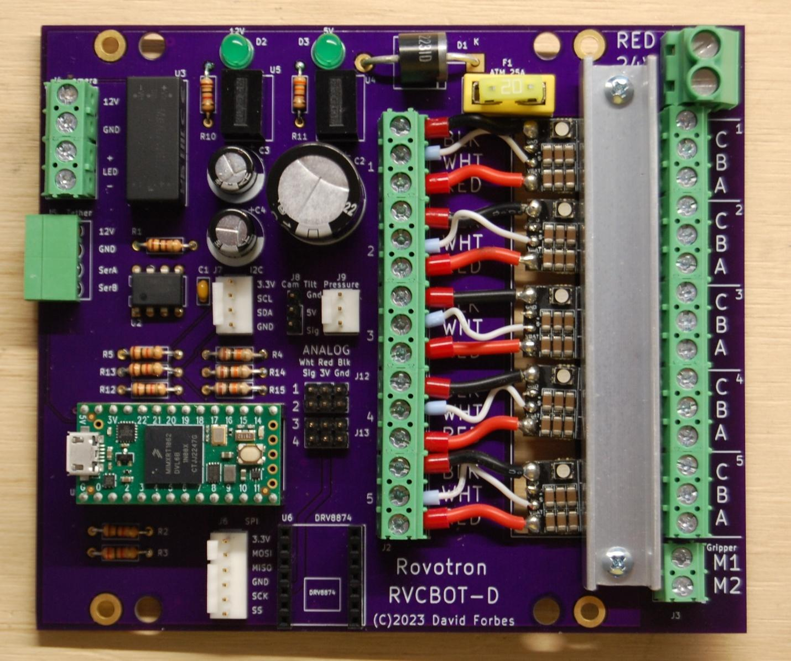

Experience required
These instructions assume that the builder has experience soldering through-hole parts onto a printed circuit board.
Building the Rovotron Control Board RVCBOT-D takes a couple of hours. It’s best to follow the instructions carefully, because there are many details of robot construction that can be done wrong and will cause you grief later. This kit and instructions have been meticulously created to allow you to succeed in getting a fully functioning ROV into the water and driving around.
It’s tempting to take shortcuts or to think that you know what comes next. Please resist that temptation. The experience of the kit designers has shown that shortcuts lead to failure.

Tools required
Tools needed
Soldering iron, fine tip, adjustable temperature preferred
Small diagonal cutters
Small long-nose pliers
#1 Phillips screwdriver
Wire strippers 16-24 AWG e.g. Ideal 45-416
Ferrule crimper

Supplies required
Solder, high quality lead-free or leaded .031" diameter or smaller, rosin or no-clean flux

Time required
The Control Board kit will take several hours to assemble. Take your time. When you stop for the day, be sure to keep all the parts safe and together with the kit, so that none are lost or borrowed.

Parts List
The parts supplied in the kit are listed below in order of installation. Check that all parts are included in the kit. Contact the supplier if there is a shortage.
In the list below, 'Step' refers to the assembly sequence. 'Marking' refers to any part number printed on the part itself. The assembly instructions begin after the parts list. Note that some parts may be confused, as they have very similar appearance. The resistors have color codes that require careful attention to tell apart, and the two voltage regulators have slightly different part numbers.

Step | Qty | Description | Designators | Markings
1 | 1 | Res 100 1/4W | R1 | Brn-Blk-Brn-Gold
2 | 5 | Res 1K 1/4W | R2, R5, R10, R12, R13 | Brn-Blk-Red-Gold
3 | 1 | Res 2K 1/4W | R3 | Red-Blk-Red-Gold
4 | 3 | Res 10K 1/4W | R4, R14, R15 | Brn-Blk-Org-Gold
5 | 1 | Res 330 1/4W | R11 | Org-Org-Brn-Gold
6 | 1 | Capacitor, 0.1uF | C1 | 104M
7 | 1 | IC, RS-485 transceiver | U2 | SN75176BP
8 | 1 | Header 4 pin RA | J5 | Green
9 | 1 | Fuseholder | F1 | Yellow
10 | 2 | LED | D2,D3 | Green
11 | 2 | Socket strip | U1 | Black 14 pin
12 | 2 | Socket strip | U6 | Black 7 pin
13 | 1 | Diode 6A 100V | D1 | GI751
14 | 1 | Regulator, LED | U3 | LDD-500L
15 | 1 | Header, 24 pin | J8, J12, J13 | black 24 pin
16 | 1 | Regulator, 5V | U4 | R-78K5.0-1.0
17 | 1 | Regulator, 12V | U5 | R-78K12-0.5
18 | 1 | Header, Molex 6 pin | J6 | White 6 pin
19 | 1 | Header, Molex 4 pin | J7 | White 4 pin
20 | 1 | Header, Molex 3 pin | J9 | White 3 pin
21 | 3 | Terminal block | J3,J4 | Green 2 pin
22 | 10 | Terminal block | J2,ESCs | Green 3 pin
23 | 2 | Capacitor, electr | C3, C4 | 470uF16V
24 | 1 | Terminal block | J1 | Green 2 pin tall
25 | 1 | Capacitor, electr. | C2 | 2200uF35V
26 | 1 | Fuse ATM 20A | F1 | Yellow 20
27 | 1 | Microcontroller | U1 | Teensy4.0
28 | 5 | Speed controller | ESCs | ESC 6S 35A
29 | 12 | Ferrule big | ESCs | 17 AWG
30 | 6 | Ferrule small | ESCs | 23AWG
31 | 1 | Tape, foam | ESCs | Red roll
32 | 1 | Heat sink | ESCs | 1/2x1/2 C channel
33 | 24 | Screws heatsink |  | 4-40x1/2 pan Phillips
34 | 24 | Nuts heatsink |  | 4-40 square

Step by step guide
Since the ROV has a transparent case, the effort you put into making sure that all the parts are installed neatly will be reflected every time you or someone else looks at the ROV. For this reason, it is recommended that you take your time to ensure that every part is aligned straight before soldering the second pin. You can reheat a pin and move the part with your fingers to align it properly. This is the method used for the factory-assembled boards.

0) The circuit board has a Top and a Bottom. The Top has the markings outlining where the parts go. The parts will be installed from the Top, with their leads or pins poking through the holes, and then soldered from the Bottom.

1 through 5) Install the resistors. First, sort them by color code according to the parts list above. Use a bright light to be able to see the colors easily, as they are similar. Bend the leads on each resistor at a 90-degree angle and insert them into the holes. It does not matter which lead goes in which hole on each resistor. Bend the leads outward at about a 30-degree angle to hold each resistor in place. Solder one lead to the PC board then look to see that the resistor is straight, then solder the other lead. Trim both leads with cutters.

6) Install the tiny capacitor C1. It does not matter which lead goes in which hole. Solder, then trim the leads.

7) Install the U2 Transceiver chip next. You might need to very carefully bend the leads inward a bit to get it to drop into the holes in the board. Make sure to align the molded dot with the square solder pad. This is at the end of the part outline that has a notch in it, next to the printed U2 symbol. After inserting the chip, bend two opposite corner leads outward at an angle, to hold it in place for soldering. Solder the eight leads. They do not need to be cut off after soldering.

8) Install the Tether header J5. The open end of the connector will hang over the edge of the circuit board. These pins are too short and stiff to bend, so let the weight of the circuit board hold the part in position as you solder the pins completely. They do not need to be trimmed.

9) Install the yellow fuse holder for F1. Solder one pin, then make sure it's straight, and solder the remaining pins.

10) Install the two green LEDs D2 and D3. Each has a flat side at the base, and the shorter lead is on this side, which goes towards the edge of the circuit board. Make sure the shape of the part matches the printed shape on the circuit board. Bend the leads outward to hold the parts in place, solder, and trim the leads.

11) Install and solder the long socket strips for U1 next. Place one strip in the board, turn it over and solder one pin in the center of the strip. Then turn the board over and make sure that the strip is straight and fully seated, heating the soldered pin as needed to adjust it. Then solder the remaining pins. Repeat with the other strip.

12) Install and solder the shorter socket strips for U6 next, following the previous instructions.

13) Install the diode D1. Bend the legs to a 90-degree angle first, forming a smooth radius. Install the diode with its striped end over the stripe shown on the board. Bend the legs apart at a 30-degree angle to hold it in place while you solder it. Trim the excess leads with diagonal cutters.

14) Install the LED regulator, using the number of pins on each and to orient it properly. If you place a small object under the opposite corner of the circuit board, this will let the board rest on the regulator, keeping the pins in place while soldering the pins. You may also bend two opposite corner pins outward a bit. The leads do not need to be trimmed.

15) Install and solder the five, three pin headers J8, J12, and J13. Solder the center pin of each first, and ensure it is fully seated and straight. If not, heat the solder and straighten. Then solder the remaining pins.

16) Install and solder the 5V regulator U4 next. Be sure to orient the part with the leads offset as shown on the board. There is a dot printed on the part at the 1 pin, which should be in the hole with a square solder pad. Double check that the part with 5 in the part number is closest to the green LED marked 5V. Check and adjust the parts’ alignment after soldering the center pin, before finishing the soldering work.

17) Install and solder the 12V regulator U5. Be sure to orient the part with the leads offset as shown on the board. There is a dot printed on the part at the 1 pin, which should be in the hole with a square solder pad. Double check that the part with 12 in the part number is closest to the green LED marked 12V. Check and adjust the parts’ alignment after soldering the center pin, before finishing the soldering work.

18) Install the white 6 pin J6 connector. Make sure the locking tab is on the side with the line on the label on the circuit board. Solder a center pin first, make sure the part is straight and fully seated, and then solder the remaining pins.

19) Install the white 4 pin J7 connector. Make sure the locking tab is on the side with the line on the label on the circuit board. Solder a center pin first, make sure the part is straight and fully seated, and then solder the remaining pins.

20) Install the white 3 pin J9 connector. Make sure the locking tab is on the side with the line on the label on the circuit board. Solder the center pin first, make sure the part is straight and fully seated, and then solder the remaining pins.

21) Install the green J3 screw terminal block for the Gripper. Make sure the large opening for the wires is facing the outer edge of the circuit board, and solder the two pins. For the J4 Camera, look closely at the terminal blocks, and note that there are little ridges and grooves at the ends. Carefully slide one block onto the other, so they become a single piece. Once the two are assembled, insert into the circuit board, and solder the four pins.

22) Install the five green screw terminal blocks J2 for the ESCs. Before installing, connect all five blocks together into one piece. Look closely at the terminal block ends. Note that there are little ridges and grooves at the ends. Carefully slide one block onto the other, so they become a single piece. Once the five are assembled, insert into the circuit board, and make sure the large openings for the wires are facing the large slot in the circuit board. Solder one pin near the middle. Cbeck that the terminal block assembly is tight against the board and adjust if necessary by pushing the block against the board while heating the soldered pin. Solder the remaining pins.

23) Install and solder the 470uF electrolytic capacitors C3 and C4 next. Observe polarity! Note that the negative lead of the electrolytic capacitors is marked with a white stripe, and the PC board marks the negative hole with a white semicircle. The positive leads of the capacitors are longer and go into the holes marked with a + sign. Bend the legs apart to hold them while soldering. Solder one lead on each capacitor, then turn the board over and make sure the capacitors are both straight. Solder the other lead on each and trim the excess lead length.

24) Install the large green J1 screw terminal block. Make sure the large opening for the wires is facing the outer edge of the circuit board and solder the two pins.

25) Install and solder the 2200uF electrolytic capacitor C1 next. Observe polarity!
Bend the legs apart to hold them while soldering. Solder one lead, then turn the board over and make sure the capacitor is straight. Solder the other lead and trim the excess lead length.

Plug in Components
26) Install the yellow F1 Fuse into the Fuseholder. Make sure it seats all the way.

27) Install the U1 Teensy into the socket. Note that the USB socket on the Teensy board is oriented toward the outer edge of the main Control board. Be static cautious.

Electronic Speed Controllers
Prepare the four or five ESCs. If you have a strafing motor, you will have five ESCs, otherwise you will have four.
Each ESC is supplied with wires for the power and control input. Three wires need to be shortened, and ferrules installed. The small black wire needs to be cut off. There is a plastic wrapper that must be removed. And a terminal block needs to be soldered in place.
To remove the plastic wrapper, lay the ESC on one edge, and use an X-Acto knife to carefully cut the plastic along the edge of the circuit board. Go slowly and be very careful not to nick any parts on the circuit board. Peel the plastic sleeve off of the board.
Carefully measure the two large red and black wires out 7/8 inch from the edge of the circuit board and cut them off. Cut off the small black wire right next to the solder connection on the circuit board. Cut the small white wire a little longer than one inch.
Very carefully not to damage the wire strands, strip ¼ inch of the insulation off the ends of the red, black, and white wires.

Ferrules
Each ESC wire connection requires a stranded wire to be inserted into a screw terminal block. This can be difficult and may create short circuits between adjacent wires if any loose strands touch other wires or terminals. For this reason, a ferrule is crimped over each stranded wire end.

A ferrule looks like a small metal tube with a plastic funnel. There are several different sizes of ferrules provided. Each has a different color funnel, to make them easy to identify.
Wire sizes are measured in different ways. In most of the world, the wire cross section area is given in square millimeters, shown as mm². In the USA, wire sizes are given in the American Wire Gauge, or AWM. This is a bizarre numbering system that only makes sense if you manufacture wire, because it indicates how many times the wire was drawn through a drawing die to make it a bit smaller.

The ferrules used on the ESCs are:
24 AWG 0.25 mm² Blue Signal
18 AWG 1.00 mm² Red Power

Once the wires on the ESC have been stripped, you can install the three ferrules. Install a red ferrule on the black wire, make sure all the strands enter the funnel. With the ferrule in place so the wire strands are just at the end of the metal tube, place the ferrule in the crimping tool, and crimp. The tool will release after the crimp is fully made. Inspect to make sure the wire is still in place, and the crimp is sufficient to hold the ferrule on.
Repeat the red ferrule installation process on the red wire.
Install and crimp a small blue ferrule on the white wire.

Each ESC needs a 3 pin green terminal block soldered on the end that does not have wires. The block must go on the “top” of the ESC, this is the side with the metal plate and large printing. The terminal block must be oriented so the openings for the wires face away from the ESC.
Set the terminal block on your work table with the pins up, and place the ESC board on top of it, upside down, with the three holes in the end of the ESC sliding over the three pins on the terminal block. Check that the square holes in the terminal block are facing the outside, not the center of the ESC. Make sure the block is perpendicular to the circuit board, and solder the center pin to the board. Pick up the ESC and inspect that the block is in the correct position. If it is not, reheat the solder and correct. Once it is in its proper place, solder the remaining pins.

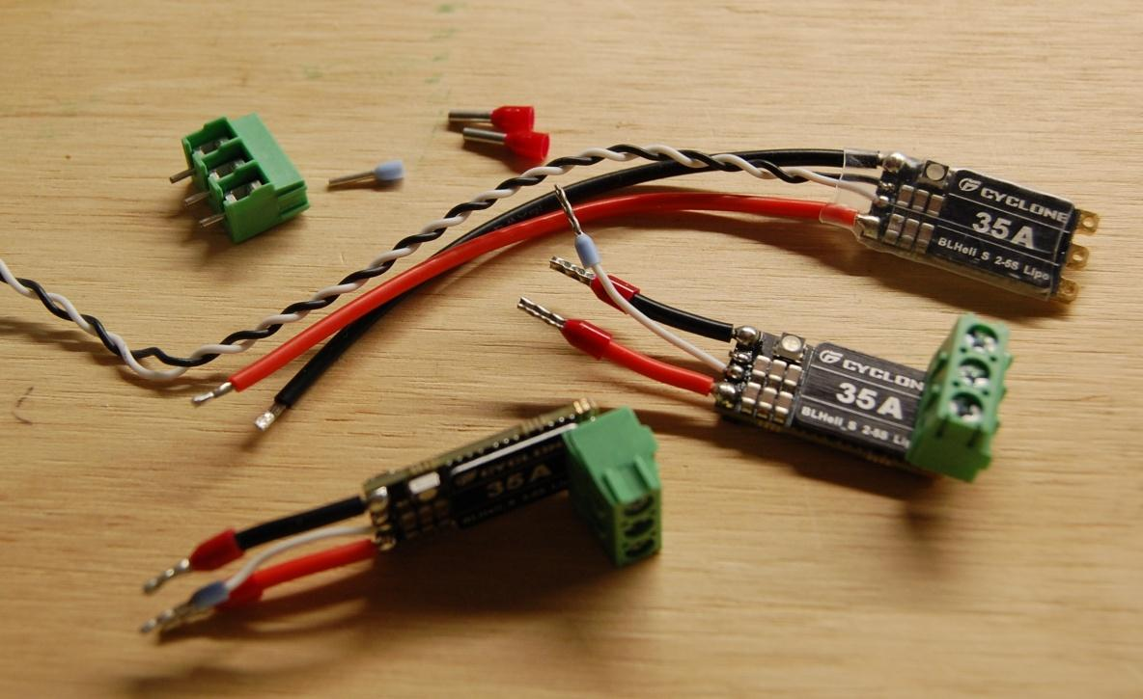

Repeat these steps with the remaining ESCs. If you damage a wire, you can use the cut off wires to replace it. Be very careful when unsoldering and soldering the wires, as the small circuit board is fragile.

31) Unroll about 4 inches from the roll of 3M foam tape. Try to not touch much of the sticky side as you do so. Apply the foam tape to the circuit board, so it covers the square blocks marked ESC. Cut off the excess tape. Remove the protective plastic from the tape.
Hold the first ESC above the RVCBOT board, next to the yellow fuse holder, so the ferrules on the three wires enter the holes in the terminal block J2. Verify the wire colors match the labels on the circuit board. Hold the ESC in position over the board so that the marked block with C B A is fully visible, not covered by the terminal block on the ESC. Carefully lower the ESC on to the tape. Press the ESC into the foam tape so that it is held in place. Use a 1/8” (3mm) slot screwdriver to tighten the three small slot head screws in the terminal block to retain the ferrules on the black, white and red wires.
With the next ESC, place the wires in the terminal block holes, then very carefully insert the terminal block tabs into the slots on the first ESC terminal block. Lower the second ESC down until it sticks to the tape. Make sure it is aligned well. Tighten the three terminal block screws to retain the wires.
Repeat with the remaining ESCs.

33 and 34) Install the aluminum heat sink bar over the ESCs with the side with the holes resting on the metal plates on the ESCs. Install a 4-40 x ½” screw and square nut at each end of the heat sink but don’t tighten them yet. Make sure the aluminum bar is not contacting any components on any of the ESCs. It should only contact the metal plates on top of them. Alternately tighten the screws gently, so the ESCs are snug.

Check that the assembly matches the photo at the beginning of the instructions.

Final Assembly
The final assembly procedure has you install the Noggin in the hull and wire it up.
The Noggin contains most of the electrical wiring. The thrusters and tether connect to the circuit board from the starboard side plate. The camera and LED connect to the circuit board.

Ferrules
Each wire connection requires a stranded wire to be inserted into a screw terminal block. This can be difficult, and may create short circuits between adjacent wires if any loose strands touch other wires or terminals. For this reason, a ferrule is crimped over each stranded wire end.

A ferrule looks like a small metal tube with a plastic funnel. There are several different sizes of ferrules provided. Each has a different color funnel, to make them easy to identify.

Wire sizes are measured in different ways. In most of the world, the wire cross section area is given in square millimeters, shown as mm². In the USA, wire sizes are given in the American Wire Gauge, or AWM. This is a bizarre numbering system that only makes sense if you manufacture wire, because it indicates how many times the wire was drawn through a drawing die to make it a bit smaller.

The ferrules used in the Rovotron Cadet are:
24 AWG 0.25 mm² Blue Tether data
18 AWG 1.00 mm² Red Thrusters and LED and camera power
12 AWG 4.00 mm² Grey Tether power

1) Strip each thruster wire 5/16”, slide on a red ferrule and crimp.

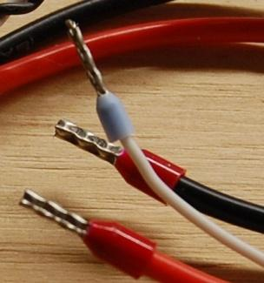

2) Strip each tether power wire 1/2”, slide on a gray ferrule, and crimp.

3) The tether data cable has 4 pairs of wire. Leave the two wires in each pair twisted together, but separate the pairs from each other. The brown/white pair is not used. On the other pairs, untwist about ¾” of each pair, and straighten the ends of the wires. Strip ¼” and slide a blue ferrule on and crimp each wire.

Camera wiring
The video balun, which converts the video signal to travel along the twisted-pair tether cable, is the black rectangle with two screw terminals on one end and a BNC plug on the other end.
This type of connector is called a bayonet.
4) Connect the camera’s BNC socket to the balun, which has a matching plug, by pushing the plug and socket together, then rotating the plug’s locking ring about 90 degrees (holding the socket at the same time) until it snaps into an indent. You can see the angled grooves on each side of the ring, to see when it is fully engaged and locked.
5) The camera power cord has a round socket. The power comes from the RVCBOT board on J4. A short red/black cable is provided to connect the camera’s power socket to the board. The red and black wires each need to have red ferrules installed. They will be wired later, so leave them sticking out the end of the brace with a few inches of free wire. Plug the power cord into the camera’s power socket firmly. It doesn’t lock together.
The camera cables are a bit messy. The top and bottom braces have pairs of holes that you can use to tie the balun and BNC connectors neatly out of the way of the camera so that it can tilt up and down freely. Arrange the cables and balun in a pleasing manner.
6) Use several zip ties to hold the cables and balun to the braces. Make sure that the BNC connector is held firmly to the center of a brace, so that it won’t come loose and short out the circuit board.

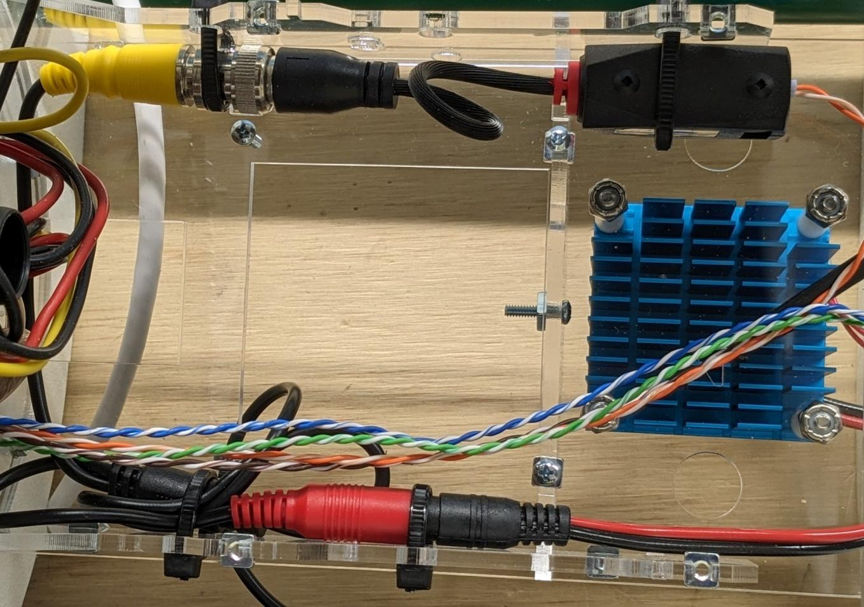

Noggin installation
The Noggin is ready to be installed into the robot hull.
It is held in place with six #8 self-threading screws with ¼” hex heads.

7) Apply silicone grease to one of the large O rings. Slip it on to the outer edge of the round area where all the wires poke into the hull. It will be retained by the Noggin Base.

Install the Noggin in place, making sure all the wires go through the large cutout on the Base.
8) Put #8 self-threading screws in two opposite Base holes and screw them in most of the way with a ¼” nutdriver. Make sure the O ring is still in place in the groove formed by the machined plastic hull, and the Base plate. If it all looks ok, install the remaining screws and tighten them. Do NOT use power tools for this.

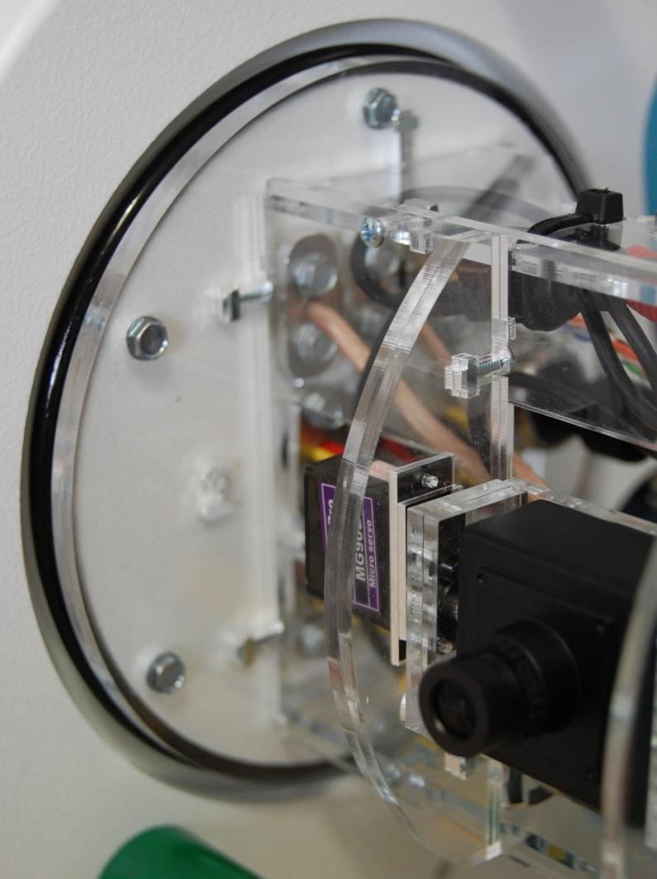

Tether video wiring
The data tether has an orange/white pair of wires. Connect the orange wire to the balun screw terminals labeled (-). Connect the white wire to the balun screw terminal labeled (+).

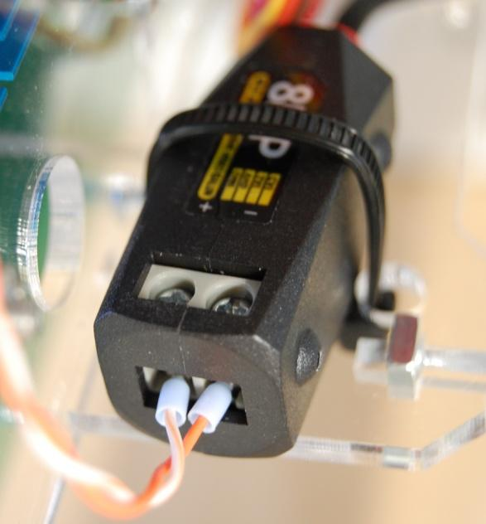

Board installation
The RVCBOT board is installed onto the braces using four 4-40 x ½” screws from the Noggin parts. The board is oriented so that the thruster terminal blocks are close to the base and the LED/camera terminal blocks are close to the LED. The components face away from the plate.
The board may need to be removed and installed several times as the robot is improved for competition. The tether connections are wired to a plug to make this easier.

Connect the tether data wires to the plug and tighten each screw. The board is labeled next to J5. The color codes are:

Blue 12v
White GND

Green SERA
White SERB

Note that there are two white wires. Keep each white wire next to its twisted pair mate.

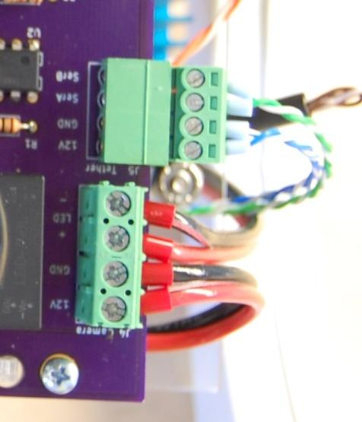

LED and camera wiring
Plug the three-pin camera tilt servo plug into the 3-pin header labeled J8 Cam Tilt. Gnd is brown. Sig is yellow.
Find the camera power cable. The red wire with a ferrule connects to the 12V terminal of J4. The black wire connects to the GND terminal. Tighten the screw terminals snugly and test by pulling on the wires.
Find the LED power cable. The red wire with a ferrule goes to LED + on J4. The black wire goes to LED -. Tighten the screw terminals snugly and test by pulling on the wires.

Tether power
Connect the copper-colored tether power wire (if the cable has two colors, otherwise use the wire without a blue stripe) to the large terminal block labeled RED at the top base corner of the board, and the power wire with a blue stripe or white strands to the terminal next to it. Tighten these terminals tightly, since they have a lot of current flowing through them and loose power wires will cause the robot to behave erratically.

Thruster wiring
Each thruster has a three-wire cable. Connect the three wires of each thruster to its ESC on the RVCBOT board in the following order from top to bottom:

Term Color Penetrator Hole
1C Yellow Top fore
1B Red Top fore
1A Black Top fore
2C Yellow Bot fore
2B Red Bot fore
2A Black Bot fore
3C Yellow Top mid
3B Red Top mid
3A Black Top mid
4C Yellow Bot mid
4B Red Bot mid
4A Black Bot mid
5C Yellow Top aft
5B Red Top aft
5A Black Top aft

Pressure sensor wiring
The pressure sensor has a supplied cable with a big three pin plug on one end and three little terminal pins crimped to the wires on the other end. These pins need to be inserted into the 3 pin Molex shell in the correct order.
9) Orient the shell so that the large holes are facing you, and the small slots are at the top. This places pin 1 at the left end. You will insert the little terminals into this block with the tiny tab facing up. The pins need to be inserted with the pin aimed up slightly so that it will slide into an internal groove in the block. Don’t force it if it won’t slide in; pull it out and try again at a different angle. The pin will snap into place when properly guided in and seated.
The order is from left to right:
Yellow
Red
Black
Plug the big black plug onto the pressure sensor body so that its clip is centered over the protruding tang on the side of the pressure sensor. Push it in until the clip snaps into place.
Plug the three pin Molex plug onto the 3 pin Molex header labeled J9 Pressure. It will only fit one way.

End cap
The end cap is a 6 inch diameter white disk. It has six holes on one side.
Apply silicone grease to the other big O-ring. Slide the O-ring onto the end cap.
Place the Noggin Port Base 14 ring on the end cap.
Install six #8 x ½” screws into the ring and end cap. Tighten snugly with a ¼” nutdriver.
Slide the acrylic tube over the Noggin, being careful to not trap any wires.
Press the end cap into the end of the tube.

Control box
The control box is a small laser-cut acrylic box that holds the RVTOP control board and its LCD status display. The LCD and board are held together with M2.5 threaded standoffs.
The board needs to be soldered together if it is supplied as a kit of parts.
The box is assembled in a similar manner to the Noggin, except that there are no nuts. The standoffs provide the screws with a place to screw into. See the RVTOP instructions to assemble the box, LCD display and the board.

Battery box
This ROV requires two 12V 18AH lead lead acid (SLA) batteries to run. The batteries and their wiring is not provided. The two batteries must be wired in series to provide 24 volts. A 20 amp fuse is required to be in line with the battery wires for safety. The wiring is shown in the photo below.
The batteries should be placed in a box for ease of carrying. Add a fuse holder and 20 amp fuse and a power switch in the wiring, and some type of connector such as Anderson PowerPole 45A connectors.

Testing
Testing the ROV must be done in a careful methodical manner to ensure good results. A water leak is the biggest problem - the water in a swimming pool is corrosive, so it may damage the electronics in the Noggin.
The electronics may also be damaged by improper wiring. The ROV circuit board is protected from damage by the fuse and reverse diode These will hopefully save the ROV in the event of the battery voltage being applied backwards.

Electronics
Double check that the Noggin is ready for power. Gently pull on each wire to make sure it’s not loose in its terminal or socket. Use a small screwdriver and tighten every terminal block screw one more time, just to be sure.
Check that the camera BNC plug is zip-tied to the brace so that it won’t flop around and short out the back of the circuit board.
Check that the tether power wires are in the right way. The RED positive power wire is really a little red strip on the copper colored wire.

Programming
The top and bottom boards each have a Teensy processor that needs to be programmed. The Arduino source code for these boards is provided on the Rovotron website.
The Arduino IDE program must be installed on whatever computer is used to program the Teensys. A laptop computer is recommended. It may be a Windows, MacOS or Linux machine. Follow the instructions on the Arduino IDE download and installation web page.
https://www.arduino.cc/en/software

The Teensy also requires an extension to Arduino called TeensyDuino to be installed after the Arduino IDE is installed. Follow the instructions on the PJRC website.
https://www.pjrc.com/teensy/td_download.html

After these two programs are installed on your computer, you may program the two Teensys using the Rovotron code that you have downloaded.

Programming the bottom board
Run the Arduino IDE and open the sketch RVCBOT-Dcode.ino
In the Tools menu, select the device under TeensyDuino to be Teensy 4.0.
The robot power doesn’t have to be on for the programming to work.
Connect a USB-A to Micro USB cable from a USB port on the laptop to the Micro USB socket on the Teensy on the RVCBOT board in the robot.
The USB port should show up in the Arduino IDE Tools > Port menu. It will probably have a strange-looking HIDxxxx port name.

Motors

<add text about motors?>

Video
The video camera will always generate a video signal on the yellow RCA jack of the top board when the tether is plugged into the top box and the robot 24V power is on. You should see an image of the scene in front of the robot on a video monitor whose yellow RCA VIDEO IN jack is connected to this jack with a video cable. If there’s no picture, check that the video monitor or television is turned on and its INPUT control (on a menu or switch) is set to AV IN or whatever the mode is that it uses for that jack to be used. Consult the instruction manual for the video monitor if you have problems.

Watertightness
A robot that fills with water can’t do much. Fortunately, the Rovotron is designed so that it is very likely to be watertight if assembled properly. The test for watertightness must be done only when all the cable holes in the starboard side are plugged with either cables or plugs, and these have been clamped properly with the retainer plates, rings, seals and screws.
The main acrylic tube must be installed with the O-rings slathered with silicone sealant. Ensure that the end cap latches are pivoted into place and are not loose.
The robot may be placed in water to a depth of a couple feet. Look for air bubbles coming from the side plates. A few bubbles will come from the motors; this is expected. Bubbles from the ends of the tube or any of the cable seals indicate a problem. Note where the bubbles are coming from and remove the robot from the water.
If the tube ends are making bubbles, check that the O-rings are seated properly and not kinked. Ensure that there is a thin layer of silicone grease completely covering the O-rings.
If a seal is making bubbles, it needs to be taken apart to be checked. Remove the end cap by sliding the retainers to the unlocked positions, then pulling on the handle. If the tube didn’t come out of the robot, then remove it by grasping at both sides and pulling.
Unscrew the two screws holding the offending seal plate. Push the wire in from the outside to free it. Then inspect the seal and the ring for problems.

Buoyancy
Ideally the ROV will be neutrally buoyant, meaning that it will sit at whatever depth it is, neither rising nor sinking. The closed loop depth control can deal with some buoyancy error, but it’s still a good idea to get the ROV as close to neutral as possible.
The easiest way to do this is to make the ROV slightly positive buoyant, and add weight as needed to get it to neutral. Having a set of weights that increment by two is ideal.

There is a feature in the software, maybe, that can hold the robot at a stable depth. Ask about this.

Actuators

Sensors
The kit is provided with a pressure sensor, used to measure depth. This has been calibrated in the software.
It is possible to add other sensors. There is an I2C connector with 3.3V power that may be used for any type of sensor with an I2C interface.

Operation

Connections
Connect the tether power cable to the battery box, observing polarity. Connect the tether data cable to the Top control box. Connect a video display to the yellow video connector on the Top control box. Connect an Xbox controller to the USB-A connector on the Top control box.

Putting in the water
Put the ROV in the water so that the top is a few inches below the surface. Watch for bubbles. A few bubbles will rise from each thruster. IF you see bubbles rising from the cable seals or the ends of the acrylic tube, pull it up to the surface immediately and locate the leaks.

Making it go
Connect the battery pack to the tether. You should see the two green LEDs on the top of the ROV circuit board glowing green. Wait a few seconds for the computers and the ESCs to boot up. The motors will make beeping noises. This is a normal feature of the ESCs. The Top control box will display telemetry such as battery voltage, water pressure, and temperatures.

Use the gamepad controls ot move the ROV. Test forward motion first using the ??? stick.
Test steering using the ??? stick.
Test diving and surfacing using the ??? stick.
Test the LED brightness pushing the ??? buttons.

Theory of Operation

ROV layout
The ROVotron ROV is designed with simplicity in mind. It provides all the needed capabilities to run the typical NURC mission, in the environment of a large public swimming pool. The major components of the ROV are the hull, Noggin, thrusters, control system, camera and lighting, sensors and tether.
The topside control system has a control board with a display and gamepad, and connection to a video monitor and battery power source. The topside box communicates with the ROV using RS-485 serial data. This data format is a bit slower than Ethernet but uses human-readable messages to simplify programming and debugging.
The camera sends analog video signal to the topside box for display on an old-fashioned video monitor. This video method is used because it has no latency, which is essential for performing delicate tasks by remote control.

Watertightness and Buoyancy
The ROV needs to be watertight and to be able to move up and down easily. The design provides for water tightness using O-rings on the Noggin cylinder and compressible rubber sealing rings around each of the wires and cables. These water seals are very simple, but they require careful fitting and compression in order to keep the water out under the pressure of a deep dive.
The cable seals are called glands. They each have a rubber sealing ring that is compressed into a hole by a plastic ring, which is pressed into the hole by an aluminum clamping plate. This is a method commonly used for sealing cables in industrial equipment. The trick was to find a suitable tiny gland material. ROVotron uses short pieces of vacuum hose made for car engines. The rings are laser-cut to the exact size needed.
The Noggin is a large cylindrical space that is full of air. This air provides buoyancy so that the ROV wants to float on the surface of the water. The two ballast bars below the Noggin provide extra mass to pull the ROV down into the water. The reason that these are at the bottom of the ROV is to keep it right-side-up and stable. An ROV without ballast at the bottom will easily tip over, making it very difficult to control. The two side plates and the handle are made of HDPE (high-density polyethylene) plastic, which has a density exactly the same as water. They hold the ROV together without affecting the buoyancy.

Power Supply
The ROVotron robot is powered by two 12V 12 AH batteries in series. These provide power through the tether to the ROV. The tether power cable is made of 12 AWG wire which is heavy enough to carry 20 Amps of current at a low enough voltage drop to ensure that the ROV receives at least 18V while driving at full speed.
The RVCBOT board provides power distribution to the various parts of the ROV. The first item is a fuse followed by a large diode wired across the 24V supply bus. This diode will short-circuit the board if the battery is accidentally connected with reverse polarity, to blow the fuse instead of destroying all the electronic parts on the board.
The board has a 24V bus that is wired to the five ESCs and the Gripper motor driver. There is an LED constant current driver module to allow the LED to operate at any desired rightness, independent of the exact supply voltage. Two switching voltage regulators provide 12V to the camera and 5V to the Teensy computer.

Computers
The ROV is controlled by two Teensy computers. One is in the top box to connect to the gamepad, and the other is in the ROV to control the motors and light, and to read telemetry data and transmit it to the top box. Each Teensy has a 32-bit ARM architecture microcontroller. Both of the computers are programmed in the C++ language, using the Arduino environment.
The top Teensy has a USB interface that is programmed to communicate with an Xbox gamepad. It also has a four line, 20 character LCD text display that shows the ROV status and telemetry.
The bottom Teensy uses several digital outputs to send speed control pulses to the motor speed controllers (ESCs) using the standard pulse width modulation (PWM) scheme used in radio-controlled models. The pressure sensor provides an analog voltage proportional to the pressure it is sensing, which is proportional to the depth of the ROV in the water.
It is possible to add features to the ROV. There is a four pin I2C header and a six pin SPI header on the bottom board.
Gamepad and Control
The gamepad is connected to the topside computer with a USB port. It is a standard Xbox gamepad of some sort. (It may be necessary to modify the Teensy Joystick library to accommodate your gamepad – contact Cathode Corner for assistance if this is the case.) The software reads the gamepad buttons and joysticks several times a second to learn which buttons are pressed and what the desired motion is. It translates these values into speed commands for each motor, and sends a list of motor speed settings to the ROV repeatedly. The ROV sends these settings to the motors as variable width command pulses.

Thrusters
The ROV moves through the water using five thrusters. There are two fore-aft thrusters at the rear of the sides, two up-down thrusters at the sides below the Noggin, and one strafing thruster behind the Noggin. The thruster placement was chosen to provide good control of the ROV motion without bucking or twisting on acceleration. Steering is provided by driving one fore-aft thruster faster than the other.
These thrusters are low-cost but high-performance units made for the hobby ROV market. They won’t last forever. Each has a brushless DC motor with stainless ball bearings. The motors require external speed controllers which are located in the Noggin.

Camera and Light
The NURC mission is run at night and the operator cannot see the ROV directly, so a camera with a light is needed to allow the operators to see what the ROV is doing. Previous experience has shown that an analog video system has a faster response than an Ethernet camera. This fast response time is needed to allow the operator to see what is happening in front of the ROV immediately, especially when manipulating objects.
The camera is a video surveillance camera with a 2.1 mm wide-angle lens. The lens gives a wide field of view that’s helpful to find objects quickly without having to steer the ROV to scan the horizon. The camera is mounted on a pivoting plate that is tilted up and down by a small RC servo motor. This allows the camera to be pointed down to see below the ROV, or up to see the tether operator, or straight ahead to see the general scene. The software tells the servo which angle to be at with a PWM signal, similar to that used by the motor speed controllers. Pressing the camera UP or DOWN buttons changes the command a bit at a time.

